LCD Controller WorkBook

Created By East

Table of contents
Chapter 1 Function Description 3
1.1 General Features 3
1.2 Top Block Diagram 5
1.3 Detailed Function Description 7
1.3.1 Memory Request Arbiter 7
1.3.2 Cursor Plane 9
1.3.3 BackGround Plane 11
1.3.4 Graphic Plane 12
1.3.5 Video Plane 17
1.3.6 Plane Mixer 19
1.4 LCD Timing Generator 21
1.4.1 LCD Interface Sync Generator 21
Chapter 2 Register Description 27
2.1 Global Control Register 29
2.1.1 LCD Controller Master Control Register 29
2.1.2 LCD Controller Status Register 29
2.1.3 Cursor XY Position Register 30
2.1.3 Graphic XY Position Register 30
2.1.3 Video XY Position Register 31
2.2 Each Plane Block 32
2.2.1 Hardware Cursor Registers 32
2.2.2 Background Control Registers 35
2.2.3 Graphic surface control register 36
2.2.4 Video Display Registers 39
2.3 LCD Interface Block 42
2.3.1 LCD Main Control Register 42
2.3.2 LCD Sync Control Register 42

Chapter 1 Function Description

1.1 General Features

- BackGround/Video/Graphic/Cursor Plane 지원
- 2048x2048 화면 처리 가능
- BackGround Plane은 단색만 지원
- Cursor Plane은 최대 64x64 사이즈만 지원
- Video/Graphic Plane은 1개씩 확장 지원 가능
- Video, Graphic, Cursor Plane은 Alpha blending(Global, Per Pixel)과 Chroma Key 지원
- Video/Graphic Plane은 감마보정 기능 지원
- Graphic Plane에 8bpp 모드 지원을 위해 Palette RAM 필요
- Video Plane의 Scale 기능 지원
- TFT LCD Type만 지원

Parameter | Planes
Parameter | Graphic | Video | Cursor | Background
Position (programmable) | 2 | 3 | 1 | 4
Resolution(max) | 2048x2048 | 2048x2048 | 64x64 | 1 color
RGB format | 8:8:8:8  5:5:5:1  4:4:4:4  5:6:5  8:8:8  8(Palletized) | YUV format  4:2:0(?)  (4:2:2) | 3:3:2  4:4:4:4  5:5:5:1 | 8:8:8
Bit per pixel | 8  16  32 | 12  16 | 8  16 | 24
Scaling factor | No | Yes | No | No
CSC | No | 3x3 matrix | No | No
Gamma Correction | LUT(24x17),  Auto Gamma | LUT(24x17),  Auto Gamma | No | No
Global Alpha Blending | 8 | 8 | 8 | No
Per pixel Alpha Blending | 1 bit  4 bit  8 bit | No | 1 bit  4 bit | No
Destination Color Key | Yes | Yes | Yes | No
LCD Output Format | 8(?)  9(?)  16(RGB565)  18(RGB666)  24(RGB888)

1.2 Top Block Diagram
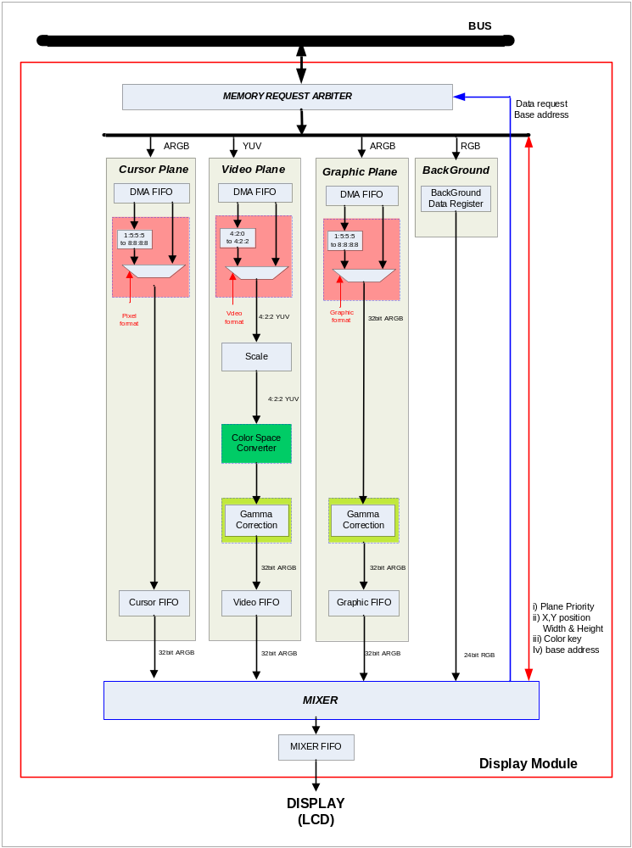

Memory Request 블록과 Cursor, Video, Graphic, Background Plane 블록, Mixer 블록 그리고 LCD 인터페이스 블록이 선언된다.
각 블록간의 데이터 처리는 적당한 크기의 FIFO를 이용한다.
각 FIFO는 항상 미리 채워져 있어야 하고, 한 프레임의 처리가 완료되면, Frame Reset 신호를 Mixer 쪽으로 전파하여서 전체 FIFO를 Flush 시켜준다.

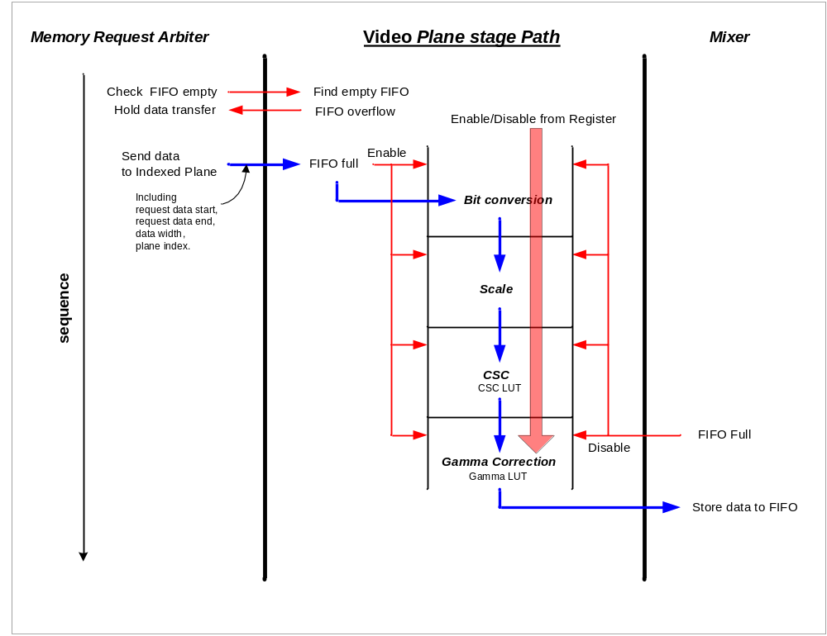
1.3 Detailed Function Description

1.3.1 Memory Request Arbiter

Memory Request Arbiter
각각의 Plane 에서 오는 Request를 받아 Bus에 data를 요청한다. Bus Request Command는 각 Plane의 Request 발생 시 Priority Mode에 의해 결정되고 Bus에서 Path 가 열리면 Slave Memory에 Read Command를 보내고, 각각의 ID에 따라서 Valid Data를 분배해 준다. Frame End시에 Base Address를 바꾸어 준다.

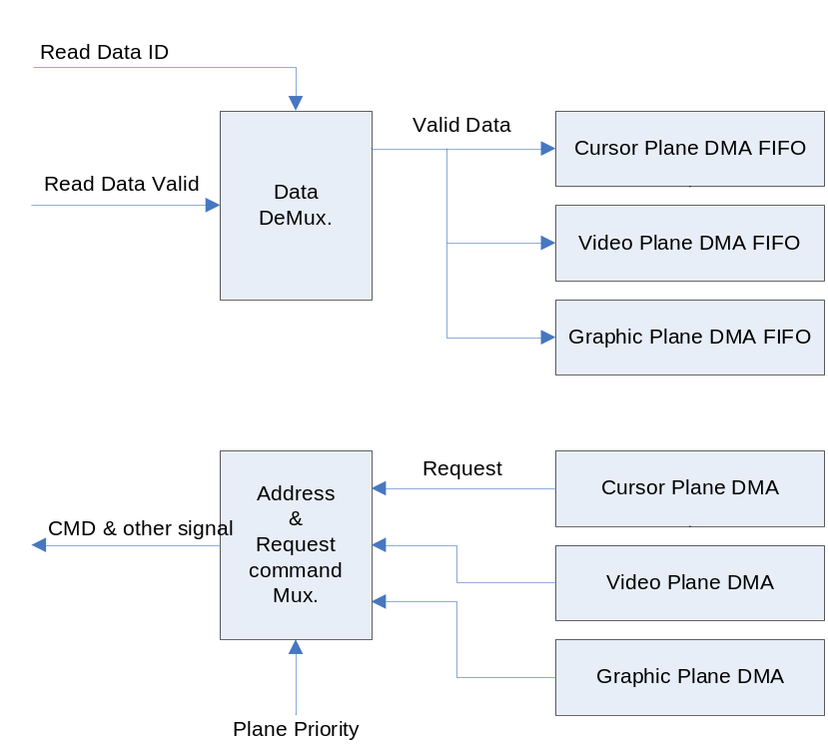

Plane DMA
Plane이 Enable 되고 새로운 Frame이 Start 되면 DMA FIFO Level을 검사하여 (Full – Maximum Burst Length)의 이하면 무조건 X, Y 개수만큼 Bus에 Read Request를 보낸다.
“ReadEnd” state에서는 다음에 요구 할 Address와 Burst Length를 미리 계산 하여 “DMA Read”에서 Read Command와 함께 보낸다.

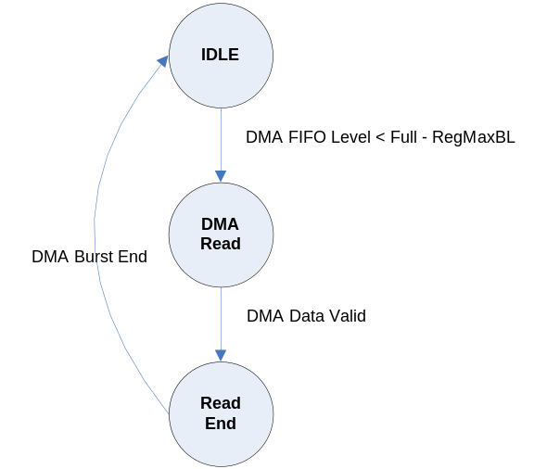

DMA FIFO는 Frame이 종료 되면 하드웨어적으로 Flush 시켜주므로 데이터가 남아 있어도 상관없으나, Empty 상황이 발생하면 안 된다. 이는 Error로 처리 해야 한다.
Empty 상황이 발생 한다면 후단(LCD Display)이 전단(Memory Bandwidth) 처리보다 빠르다는 상황이거나 잘 못 설계된 상황이라고 볼 수 있다.
따라서, 전자라면 후단 처리를 늦추도록 하면 되지만, 후자라면 재 설계해야 한다. → Die

DMA FIFO Write는 Data Valid와 함께 Full이 아닐 때까지 X, Y 개수만큼 계속 Write 하고, DMA FIFO Read는 각 Plane 에서의 Request에 의해 바로 Data를 내 놓아야 한다.

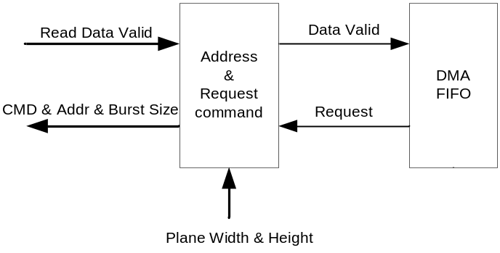

1.3.2 Cursor Plane

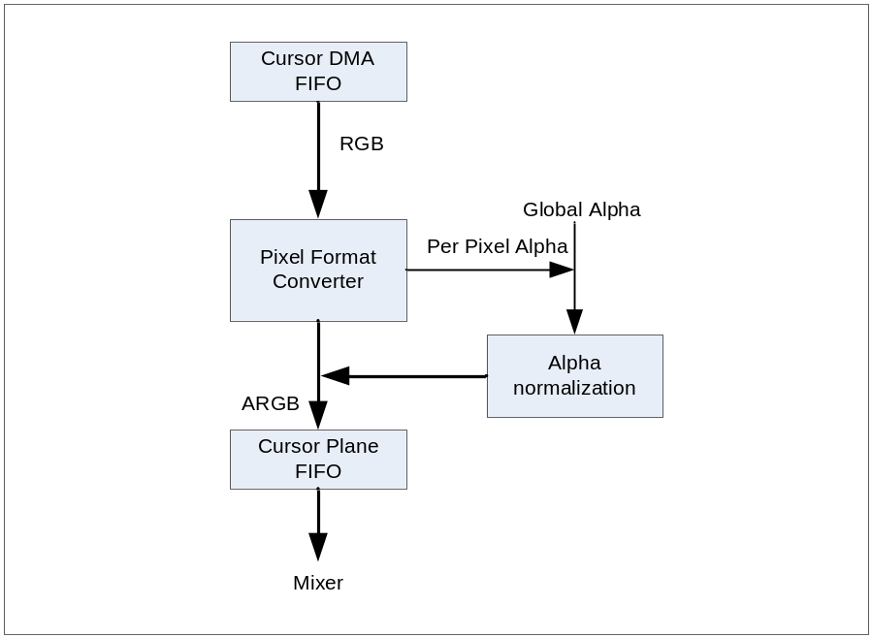

Cursor Plane은 Hardware Cursor를 지원하고 Cursor Image는 메모리에 놓여 있어야 하고, Mixer에서 다른 Plane들과 섞인다.
Cursor Plane은 Mixer에서 섞일 수 있는 Cursor Image를 만들어 보내는 역할을 한다.

Pixel Format Converter
- Normalize to 32Bit ARGB 8888
- 8bit rgb332 [RGB]
- 1bit alpha + 15-bit rgb555 [ARGB]

Alpha Blending Mode
- Global Alpha Blending
- Per Pixel Alpha Blending
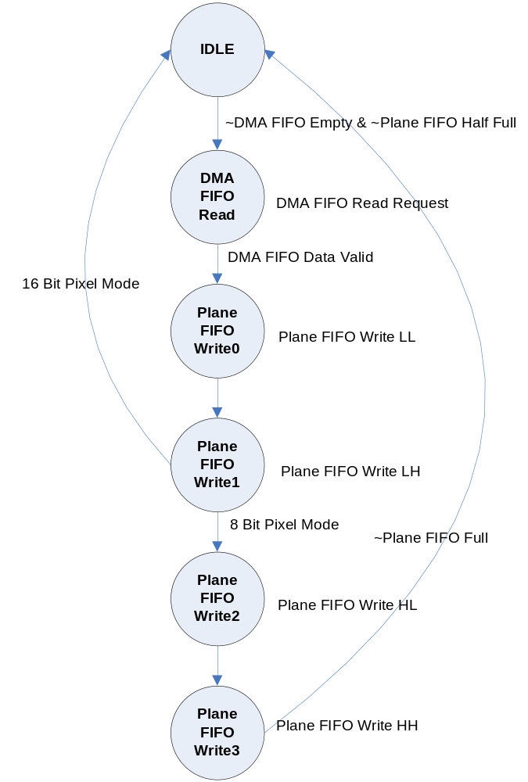

Pixel Mode
- 8bit Mode
  - Width/4 만큼 DMA FIFO Read Request를 보낸다.
- 16bit Mode
  - Width/2 만큼 DMA FIFO Read Request를 보낸다.

Pixel Alpha 모드일 경우에는 DMA FIFO Read Data의 Alpha 값을 참조하고, Global Alpha 모드일 경우에는 Register 값을 참조하여 DMA FIFO Read Data에 Alpha Blending 값을 적용하여 Plane FIFO에 Write 한다.

Plane FIFO Half Full = Plane FIFO Full Level - 4

1.3.3 BackGround Plane

BackGround Plane은 단색이고 Chroma Keying/Alpha Blending을 안하며, Plane 중 가장 낮은 Blend Position을 가진다(i.e., below graphics, video, and cursor).

The background color plane is used only if none of the other three planes fill a given pixel
opaquely. If any other plane fills a pixel opaquely, the background color will not be used when calculating the final color of that pixel.

1.3.4 Graphic Plane

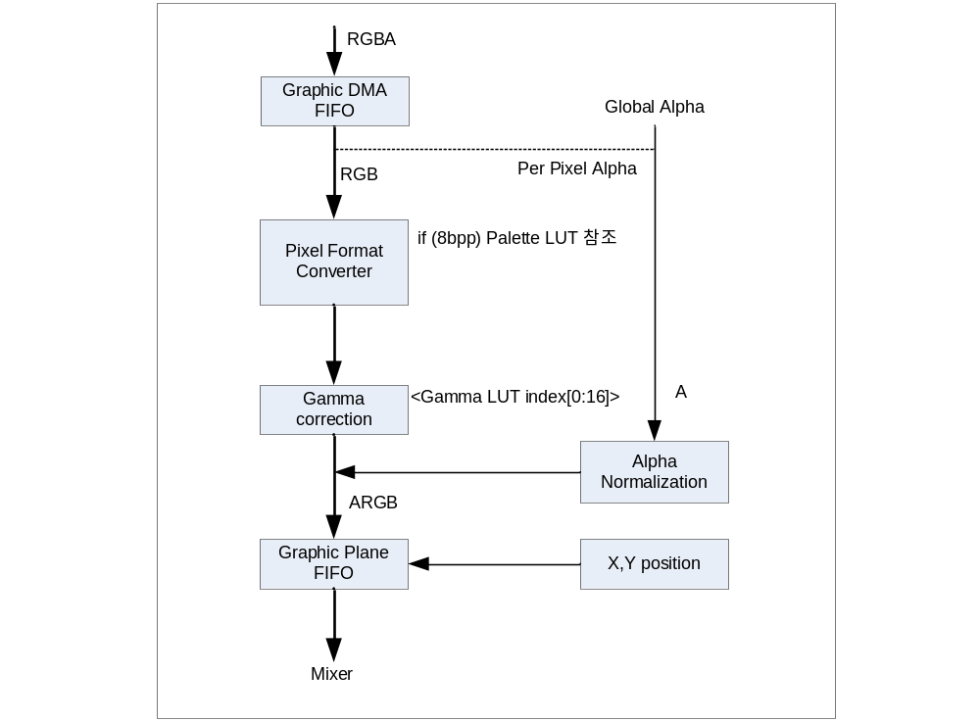

Pixel Format Converter
- Normalize to 32Bit ARGB 8888
- 8bpp [RGB]
- 1-bit alpha + 15-bit rgb555 [ARGB]
- 16-bit rgb565 [RGB]
- 24-bit rgb888 [RGB]
- 8-bit alpha + 24-bit rgb888 [ARGB]

8bpp는 Palette LUT를 이용해야 한다. → 구현?
- GIF Format이 이를 지원
- 256x24 Single Port SRAM 필요 or Main Memory 이용
- CPU Write and Read and LCD Read Port 필요
8bpp 데이터가 Palette LUT의 Address가 된다.
초기에 Palette Data를 만들어 줘야 한다.
1 Clock의 Latency를 가지므로 다른 모드일 경우에도 한 클럭씩 뒤로 밀어야 한다.

Alpha Blending
Pixel Alpha와 Global Alpha는 동시에 선택하면 Global Alpha만 적용된다.
Alpha Blending Mode에 의해 선택
- No Alpha Blending Mode
- Per Pixel Alpha Mode : Pixel마다 Alpha Blending을 한다는 의미
- 1bit Alpha : 0 → 0x00, 1 → 0xff
- 4bit Alpha : 상 하위에 나눠서 Copy → 2D에서 지원 안 함.
- 8bit Alpha : bypass

- Global Alpha Mode : Graphic Plane 전체에 Alpha Blending을 한다는 의미
Insert Global Alpha Value From Register

FIFO Read
- 8 Bit Pixel Mode : 한번 읽어서 4번 처리한다.
- 16 Bit Pixel Mode : 한번 읽어서 2번 처리한다.
- 32 Bit Pixel Mode : FIFO에서 한번 읽어서 Bypass 한다.

16 Bit Pixel Mode의 예를 들면,
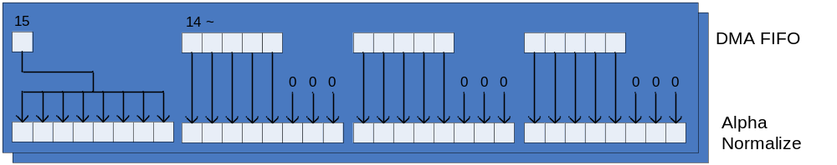

1:5:5:5 format 은 32bit data 에 2 pixel data 를 가지고 있으므로 FIFO에서 같은 address의 데이터로 두 개의 pixel data를 만들어서 Gamma쪽으로 보낸다.
24bit RGB는 32bit 처리처럼 한다. 즉, Write시에 “zero+RGB”로 한다.
FSM을 이용하면 (IDLE → DMA FIFO Read → Plane FIFO Write Low → Plane FIFO Write High) 이런 식이다.
DMA FIFO가 Empty가 아니고 Graphic FIFO의 Almost Full(Full-Latency(Gamma Correction, max4)만 아니면 Graphic FIFO에 Write가 가능하므로 설정된 Width와 Height 만큼 Read Request를 보내서 무조건 읽는다.

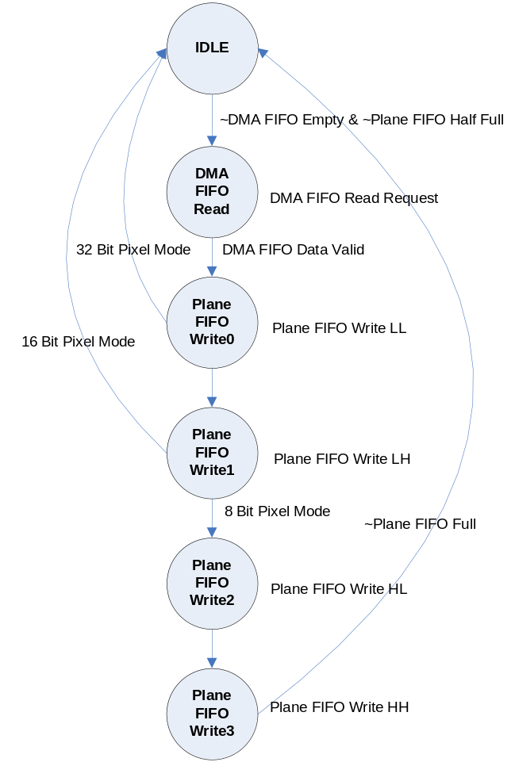

Gamma Correction은 DMA FIFO Data Valid, Plane FIFO Write0, Plane FIFO Write1, Plane FIFO Write2 State에서 한다.
Gamma Correction이 종료되면 Graphic FIFO에 Plane FIFO Write0, Plane FIFO Write1, Plane FIFO Write2, Plane FIFO Write3 신호로 Write 한다.
Mixer에서 Read Request를 보내면 Graphic FIFO가 Empty 상황만 아니면 Mixer쪽으로 Valid를 항상 내보낸다.
Gamma Correction

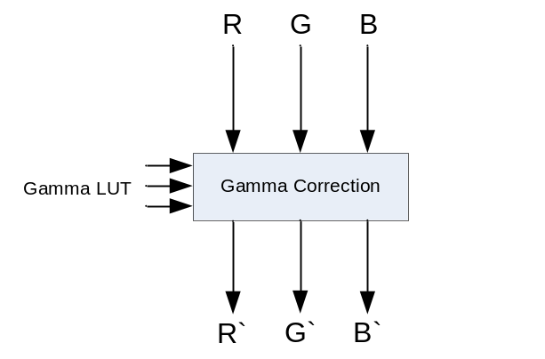
R' = T[κR] + ( T[κR+1] – T[κR] ) * (αR) /16
G' = T[κG] + ( T[κG+1] – T[κG] ) * αG) /16
B' = T[κB] + ( T[κB+1] – T[κB] ) * αB) /16

κR : the upper nibble of a Red
αR : the lower nibble of a Red

LUT | Gamma = 1.0 | Gamma = 1.4
0 | 0 | 0
1 | 16 | 35
2 | 32 | 57
3 | 48 | 77
4 | 64 | 95
5 | 80 | 111
6 | 96 | 127
7 | 112 | 141
8 | 128 | 156
9 | 144 | 169
10 | 160 | 182
11 | 176 | 195
12 | 192 | 208
13 | 208 | 220
14 | 224 | 232
15 | 240 | 244
16 | 255 | 255

The gamma corrected color value (for R, G, and B) is calculated by:
1) Lookup κR +1 in the LUT index column of Table.
2) Select the gamma value in the right columns of Table.
This is T[κR +1].
3) Lookup κR in the LUT index column of Table.
4) Select the gamma value in the right columns of Table.
This is T[κR].
5) Interpolate T[κR] and T[κR +1] using αR.
As an example, assume an RGB color of R=135, G=222, and B=053 (all values are decimal) being
gamma corrected using the gamma = 1.4 values in Table

RED
1) κR = upper nibble of 135 = 8
2) αR = lower nibble of 135 = 7
3) T[κR] = 156
4) T[κR +1] = 169
5) Interpolate T[κR] & T[κR +1]
6) Resulting red value is: 162
The same process can be applied to the original G and B values to obtain the gamma corrected pixel color.

*** Gamma를 Enable 하고 Chroma Key를 적용하면 Gamma에 의해 변형된 값의 Chroma Key를 적용해야 한다.
즉, 위의 1.4 Gamma를 적용할 경우에는 0xFFFFFF 대신 0xF2F2F2를 적용한다.

1.3.5 Video Plane

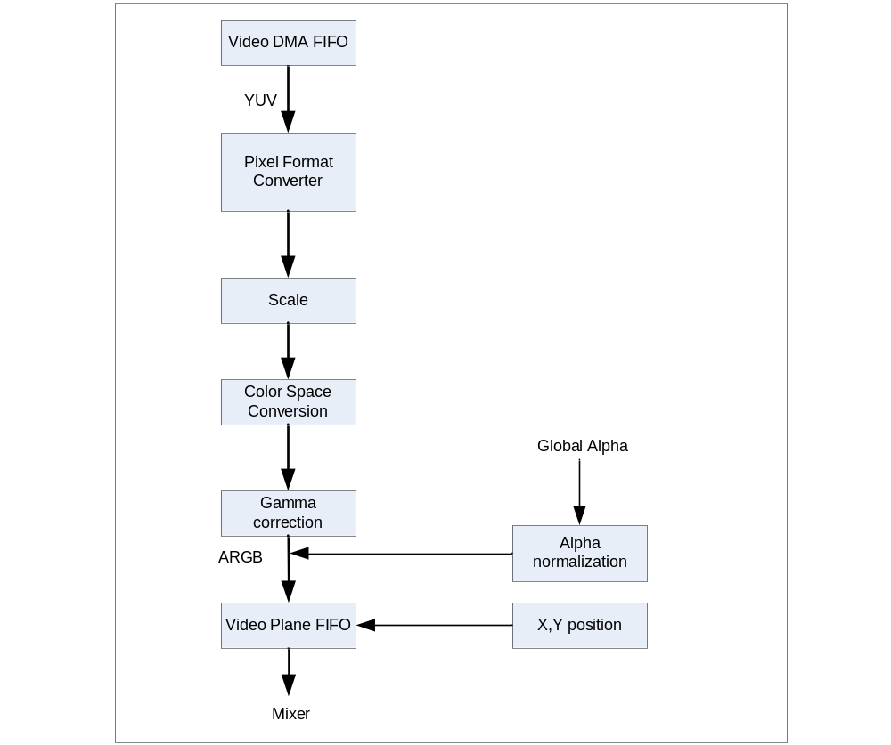
Pixel Format Converter
- YUV420 Planar Mode[YUV12] → Not Supported Yet.
- YUV422
- 16bit YUV 4:2:2 UY0VY1 (U lsb) [UYVY / UYNV]
- 16bit YUV 4:2:2 VY0UY1 (V lsb)
- 16bit YUV 4:2:2 Y0UY1V (Y0 lsb) [YUY2 / YUNV / V422]
- 16bit YUV 4:2:2 Y0VY1U (Y0 lsb) [YVYU]
Scaler → Not Support Yet.
- Up Scale
- Down Scale

Color Space Conversion

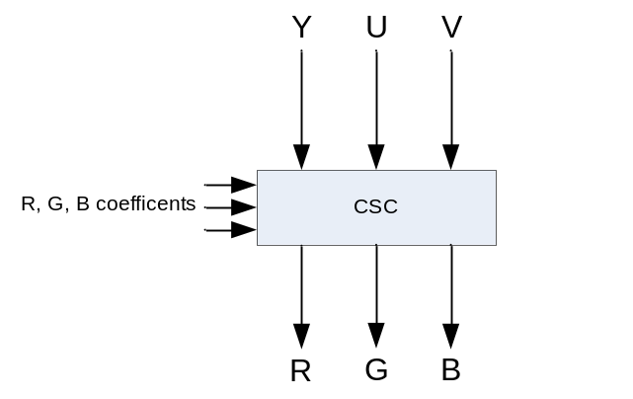
R = ( 298 * ( Y - 16 ) + ( 409 * ( V - 128 ) ) >> 8
G = ( 298 * ( Y – 16 ) + ( 208 * ( V – 128 ) – 100 * ( U – 128 ) ) >> 8
B = ( 298 * ( Y – 16 ) + ( 512 * ( U – 128 ) ) >> 8

Color Space Coefficent register → Not Support.

Alpha Blending은 Global Alpha Blending만 지원 한다.

Gamma Correction은 Graphic Plane 과 같다.

1.3.6 Plane Mixer

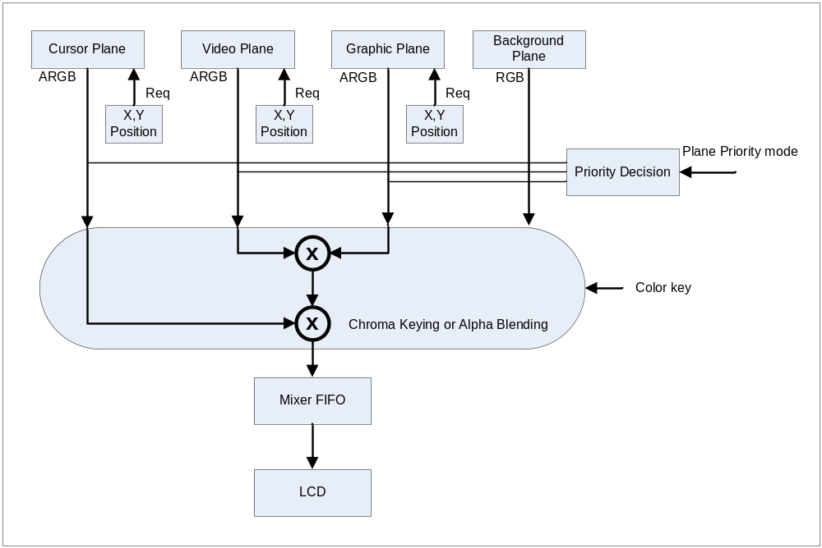

Mixer Operation

The four streams are combined by the mixer to create the final image that appears on the
display. The mixer combines the streams based on their blend position (top, middle, bottom, background), alpha values, and chroma-key

Display할 LCD의 Width, Height 만큼 Count를 진행하다가, FIFO의 일정 Level(Full minus Blending Latency)에 도달하면 Hold되어야 한다.
위 Counter를 토대로 해당 Plane의 좌표와 비교하여, 일치하면 해당 Plane쪽에 Data Request 신호를 보낸다. 이때, 해당 Plane은 FIFO에 미리 준비한 데이터를 Data Valid와 함께 내 놓는다.
해당 Plane의 데이터는 우선순위에 의해 Chroma-Key나 Alpha-Blending 처리된 후 LCD Display를 위하여 Dual Port FIFO에 Write 된다.
FIFO Write는 이미 Blending(Chroma, Alpha, Priority) Latency를 고려하여 처리되었으므로 FIFO Full이 발생하지 않는다. 만약, 발생한다면 Error다.
FIFO Read는 LCD에서의 데이터 요구에 의해 끊김 없이 보내야 한다.
즉, FIFO의 Full, Empty 신호가 발생하면 Data는 Corrupt 되었으므로, Flag를 띄워 Reset 시켜 주어야 한다.

*** Mixer는 LCD에서 데이터를 요구하기 전에 준비 되어 있어야 하므로 먼저 시작 되어야 한다.
*** FIFO는 LCD에서 한 프레임의 Display가 완료 되면 Clear 시켜서 프레임 단위의 프로세스를 진행 한다.

Plane Priority Select

Cursor와 Background Plane의 Position은 고정되어 있고 나머지 Plane에 대해서 Priority를 선택 할 수 있다.

The 24-bit chroma-key value is programmed independently for the graphics, video, and cursor planes (background does not support chroma-key).

cf) Chroma Key Mask(?)

Plane Chroma-Key & Alpha Blending
Plane priority가 결정되면, Chroma-Key와 Alpha Blending 중 모드 선택에 의해 하나를 진행 한다. 1 클럭의 Latency를 갖는다.

Plane Chroma-Key , the simple priority mode,
Processing is performed according to the transparent color defined for each layer. When the color is a transparent color, the value of the lower layer is used as the image value for the next stage; when the color is not a transparent color, the value of the layer is used as the image value for the next stage.
Pview = Pnew (when Pnew does not match transparent color)
= Plower (when Pnew matches transparent color)

Alpha Blend mode,
Pview = Pnew × α + Plower × (1 – α), (0≤α≤1)
(Upper image × Blend ratio) + (Lower image × (1 – Blend ratio))
Small Area →
Pview = α(Pnew - Plower) + Plower, (0≤α≤1)

1.4 LCD Timing Generator

1.4.1 LCD Interface Sync Generator

Support TFT LCD Only

Horizontal Timing Generator:
The Horizontal control logic consists of a 4-state State machine and a counter that enables the state transition when expires. The counter is implemented as a down counter clocked by the LCDCLK clock. Counting is enabled only when the DecH (Decrement) signal is sampled HIGH on rising edge of the clock. The signal HEq1 is asserted when the horizontal counter reaches a value of “1” and HEq0 is asserted when the horizontal counter reaches a value of “0”. These signals are used inside the state machine to find out whether the counter has expired or not.
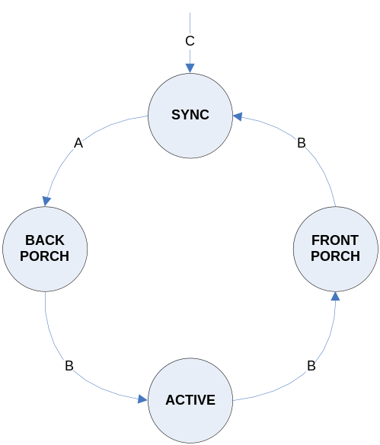

HORIZONTAL STATE TRANSITION CONDITIONS:
A – If LcdEn = 1 or EnLowFlag = 1 or vertical state != SYNC and if horizontal count = 0 and (DelRisingNext = 1)
B – If Horizontal count = 0 and (DelRisingNext = 1)
C – If DMA master error interrupt (AhbMBESyncLclk) = 1
EnLowFlag to indicate that LcdEn has gone Low in VSYNC state

The functions performed in each state are as follows

Horizontal SYNC State: Initial state.
· If the LcdEn bit is set to “1” to enable the LCD controller or if the vertical state machine is out of SYNC state; Line pulse signal is enabled and the counter is decremented on each panel clock (CLCP). When the counter expires; the FrameStart signal is asserted to start the DMA (AHB Master) if the Vertical state machine is in SYNC state and vertical count is equal to “1”, Line pulse is de-asserted, horizontal front porch count is loaded in to the horizontal counter and the state machine advances to the BACKPORCH state.
· If the LcdEn bit is zero and the vertical state machine is in SYNC state and if EnLowFlag is set then the counter is still decremented on each panel clock (CLCP) and the state machine proceeds to the next state as usual but the Line pulse is not enabled and the FrameStart signal is not asserted as it is only the dummy state transition and the display is inactive.

Horizontal BACKPORCH state: The BACKPORCH State introduces a wait period of HBP (Back porch width) before the active display period starts. The counter is decremented on each panel clock (CLCP). When the counter expires; the Clocks per line (CPL) count is loaded in to the counter.

Horizontal ACTIVE state: In this state the counter counts the panel clocks. Output Enable signal is asserted. When the counter expires; OutputEnable signal is de-asserted, the signal LEStartSet is asserted to start the generation of the line-end signal, Horizontal front porch value (HFP) is loaded in to the counter and the state machine advances to the FRONT_PORCH state.

Horizontal FRONTPORCH State: This State introduces a wait period of HFP (Front porch width) after the active period of the display. The Horizontal counter is decremented on each panel clock (CLCP). When the horizontal counter expires; HSW value is loaded in to the counter, if the LcdEn bit is still HIGH or the vertical state machine is not in SYNC state the line pulse signals is asserted and the state machine moves back to the SYNC state.
The FrameRst signal is issued at the end of each frame to re-initialize the DMA master and the DMA FIFO/Plane FIFO/Mixer FIFO. The FrameStart signal is asserted only after receiving acknowledgement of the frame reset (FrameRst) signal because the DMA master samples the FrameStart signal only when it re-enters the START_FRAME state.

Vertical Timing Generator:
The vertical timing controller consists of a 4-state state machine and a counter which enables the state transition when expires. The counter is implemented as down counter clocked by the LCDCLK clock. Counting is enabled only when the DecV (Decrement) signal is sampled HIGH on rising edge of the clock. One LCDCLK clock wide pulse called EndOfLine is connected to the DecV input of the counter to decrement the count at the end of each line of the display. The signal VEq1 is asserted when the vertical counter reaches a value of “1” and VEq0 is asserted when the count reaches a value of “0”. These signals are used inside the state machine to find out whether the counter has expired or not.
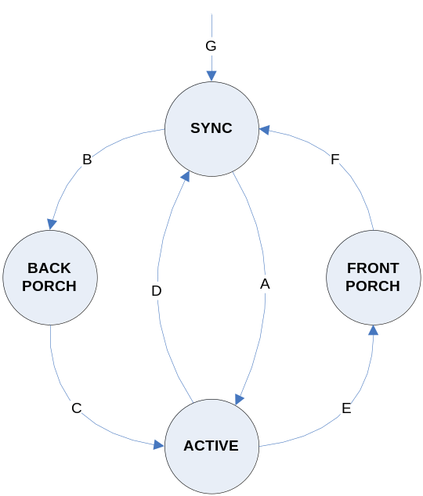

VERTICAL STATE TRANSITION CONDITIONS:
A – If EndOfLine = 1 and Vertical count = 0 (VEq0 = 1) and EnLowFlag = 0 and Vertical back porch value = 0(VBPEq0 = 1)
B – If EndOfLine = 1 and Vertical count = 0 (VEq0 = 1) and EnLowFlag = 0 and Vertical back porch value != 0(VBPEq0 = 0)
C – If EndOfLine = 1 and Vertical count = 1 (VEq1 = 1)
D – If EndOfLine = 1 and Vertical count = 0 (VEq0 = 1) and Vertical front porch value = 0(VFPEq0 = 1)
E – If EndOfLine = 1 and Vertical count = 0 (VEq0 = 1) and Vertical front porch value != 0(VFPEq0 = 0)
F – If EndOfLine = 1 and Vertical count = 1 (VEq1 = 1)
G – If DMA master error interrupt = 1

The functions performed in each state are as follows

Vertical SYNC State: Initial state. If the LcdEn bit is set to “1” to enable the LCD controller:
The state machine loads Vertical sync width (VSW) in to the vertical counter and the counter is decremented at the end of each line of the display.
· The Frame pulse signal is enabled if the display type is TFT and the EnLowFlag is zero.
While in this state, If the LcdEn bit is cleared to disable the LCD controller; a flag called EnLowFlag will be set and all the panel timing signals are driven to their inactive state value. The vertical counter is reloaded with the VSW value and decremented at the end of each line. When the counter expires and if the LcdEn bit is still zero it reloads the vertical counter again and continues to stay in this state itself. Other wise if the LcdEn bit is
set; the counter is reloaded with the VSW value, the EnLow flag is cleared to enable the LCD panel signals and the counter is decremented as usual. This is being done deliberately to prevent the toggling of the LCD panel signals due to momentary setting and clearing of the LcdEn bit while the state machine is in this state.
· If the vertical counter has expired and the LcdEn bit is HIGH and EnLowFlag is zero: Frame pulse is deasserted for TFT panel and the state machine advances to the next state based on the vertical back porch value. If the Back porch (VBP) is programmed with a value of zero; LPS value is loaded in to the counter, VCOMP status signal is asserted if it is programmed for “Start of ACTIVE period” and the state machine advances to the ACTIVE state. Otherwise VBP value is loaded in to the counter, VCOMP status signal is
asserted if it is programmed for “Start of BACKPORCH period” and the state machine advances to the BACKPORCH state.

Vertical BACKPORCH State: This State introduces a wait period of VBP (vertical back porch width) before the vertical active display period starts. The counter is decremented by “1” at the end of each line. When the counter
expires; VCOMP status signal is asserted if it is programmed for “Start of ACTIVE period”, LPS count is loaded in to the counter and the state machine advances to the ACTIVE State.

Vertical ACTIVE State: This state decides the vertical active period of the display. While in this state;
· The Frame pulse is asserted at the rising edge of the first panel clock (CLCP) of the first line and deasserted at the rising edge of the first panel clock of the second line.
· If the vertical counter has expired, the state machine advances to the next state based on the Front porch count (VFP). If the VFP is programmed with a value of zero; FrameRst signal is asserted to reset the front end of the controller (DMA FIFO/Plane FIFO/Mixer FIFO), VCOMP status signal is asserted if it is programmed for “Start of SYNC period”, Frame pulse is enabled, EnLowFlag is asserted if the LcdEn bit is cleared and the state machine moves back to the SYNC state. Otherwise VFP value is loaded in to the counter, VCOMP status signal is asserted if it is programmed for “Start of FRONTPORCH period” and the state machine advances to the FRONTPORCH state.

Vertical FRONTPORCH State: This State introduces a wait period of VFP (vertical front porch width) at the end of active period before entering the SYNC State. The Vertical counter is decremented by “1” at the end of each line. When the counter expires, FrameRst signal is asserted to reset the front end of the controller (DMA FIFO/
Plane FIFO/Mixer FIFO), VCOMP status signal is asserted if it is programmed for “Start of SYNC period”, VSW value is loaded in to the counter, EnLowFlag is asserted if the LcdEn bit is cleared and the state machine moves back to the SYNC State.
When the vertical state machine is in any of the valid states and if the AHB master error interrupt is sampled HIGH then all signals are driven to their reset state value, vertical sync width is loaded in to the vertical counter, the next state is initialised to the SYNC state and waits for the clearing of this interrupt. When this interrupt is cleared the state machine moves to the SYNC State and starts the display of the new frame if the LcdEn bit is set.
If the LcdEn bit is cleared when the vertical state machine is in other than the SYNC state, the current frame display will be completed and at the end of the frame it samples the LcdEn signal; if it is low it enters the SYNC state and stops further display of the frame. This means, if the LCD controller is disabled at the middle of the frame software has to wait till the current frame is over and then only program for the new mode if needed. Otherwise the current frame gets corrupted.

DE or Output Enable signal logic:
For TFT display this signal is used as DataEnable to latch the panel data. The signal OENext generated from the horizontal timing state machine drives this pin.

Line-End signal logic:
The Line-End signal generation logic consists of a seven-bit counter and control logic to load and decrement the counter. The Line-End signal is of 4 LCD clock (LCDCLK) wide and generated after the last panel clock (CLCP) of the line with a programmable delay from the rising edge of the last panel clock. When the LEStartSet signal is sampled HIGH on the rising edge of the LCD clock (LCDCLK), the counter is loaded with the LE delay value and decremented on each LCDCLK. When the counter expires, The Line-End signal is asserted and the counter is loaded with a value of “3”. The counter is decremented once again, when the counter expires, the Line-End signal is de-asserted and the control logic waits for the next LEStart signal. The frame pulse (CLFP), line pulse (CLLP) and the DataEnable (CLDE) signals are inverted if the respective invert option (IVS, IHS, IEO) is enabled in the timing register2 and clocked out to the output port on the rising edge of the LCD clock (CLCLK). Also these signals are gated with the LCD panel power enable signal before clocking them out. Hence all the LCD panel timing signals (CLFP, CLLP, CLDE, CLCP) are driven out only when the LcdPwr bit is set and the LcdEn bit is set (or if the LCD controller is in active display period).

Chapter 2 Register Description

Register | Address | R/W | Description | Reset Value
LCDMCON | 0x00 | RW | LCD Controller Master Control Register | 0
LCDMSTS | 0x04 | R | LCD Controller Master Status Register | 0
CPOS | 0x10 | RW | Cursor XY Position Register
GPOS | 0x14 | RW | Graphic XY Position Register
VPOS | 0x18 | RW | Video XY Position Register
CCON | 0x20 | RW | Cursor Control Register | 0
CBLND | 0x24 | RW | Cursor Blending Register | 0
CBMOD | 0x28 | RW | Cursor Blending Mode Register | 0
CBASE | 0x2C | RW | Cursor Stride Base Register | 0
CADDR | 0x30 | RW | Cursor Stream Address Register
CADDR2 | 0x34 | RW | Cursor Stream Address 2 Register
CBLINK | 0x38 | RW | Cursor Blink Control Register
BGCOL | 0x40 | RW | Background Color Register | 0
GCON | 0x50 | RW | Graphics Surface Control Register | 0
GBLND | 0x54 | RW | Graphics Blending Register | 0
GBMOD | 0x58 | RW | Graphics Blending Mode Register | 0
GBASE | 0x5C | RW | Graphics Stride Base Register | 0
GADDR | 0x60 | RW | Graphics Stream Address Register | 0
GPALM | 0x64 | RW | Graphics Palette Address Register | 0
GGAMMA | 0x100~  0x140 | RW | Graphics Gamma Slope Register
VCON | 0x70 | RW | Video Surface Control Register | 0
VBLND | 0x74 | RW | Video Blending Register | 0
VBMOD | 0x78 | RW | Video Blending Mode Register | 0
VBASE | 0x7C | RW | Video Stride Base Register | 0
VADDR | 0x80 | RW | Video Stream Even Address Register | 0
VADDR2 | 0x88 | RW | Video Stream Odd Address Register | 0
VGAMMA | 0x200~  0x240 | RW | Video Gamma Slope Register
LCDCON | 0xE0 | RW | LCD Control Register | 0
HSYNC0 | 0xF0 | RW | Horizontal Sync0 Register | 0
HSYNC1 | 0xF4 | RW | Horizontal Sync1 Register | 0
VSYNC0 | 0xF8 | RW | Vertical Sync0 Register | 0
VSYNC1 | 0xFC | RW | Vertical Sync1 Register | 0

2.1 Global Control Register

2.1.1 LCD Controller Master Control Register

Register | Address | R/W | Description | Reset Value
LCDMCON | 0x00 | RW | LCD Controller Master Control Register | 0

Register | Bit | Description | Reset Value
 | 31:2 | Reserved | 0
BLEND_POS | 1 | Plane Position : 각 Plane에 대한 overlay priority bit. (Alpha Value 와 Colorkey setting에 따라 달라질 수 있음)  0 : Video>Graphic  1 : Graphic>Video | 0
INTEn | 1 | Frame의 전송이 끝나면 인터럽트를 걸지 여부를 결정한다 | 0
SWReset | 0 | Reset LCD Controller  1 : Reset  0 : Set | 0

2.1.2 LCD Controller Status Register

Register | Address | R/W | Description | Reset Value
LCDMSTS | 0x04 | R | LCD Controller Master Status Register | 0

Register | Bit | Description | Reset Value
 | 31:14 | Reserved | 0
CDMAFIFOErr | 13 | Cursor Plane DMA FIFO Error(OverRun/UnderRun) | 0
VDMAFIFOErr | 12 | Video Plane DMA FIFO Error(OverRun/UnderRun) | 0
GDMAFIFOErr | 11 | Graphic Plane DMA FIFO Error(OverRun/UnderRun) | 0
 |  | Reserved
CFIFOErr | 10 | Cursor Plane FIFO Error OverRun/UnderRun) | 0
VFIFOErr | 9 | Video Plane FIFO Error(OverRun/UnderRun) | 0
GFIFOErr | 8 | Graphic Plane FIFO Error(OverRun/UnderRun) | 0
CFIFOErr | 7 | Cursor Plane FIFO Error(OverRun/UnderRun) | 0
VFIFOErr | 6 | Video Plane FIFO Error(OverRun/UnderRun) | 0
GFIFOErr | 5 | Graphic Plane FIFO Error(OverRun/UnderRun) | 0
MIXFIFOErr | 4 | Mixer FIFO Error(OverRun/UnderRun) | 0
 | 3:2 | Reserved
ENDFrame | 1 | End of Frame  When Read, Auto Cleared | 0
INTSTS | 0 | Interrupt Status | 0

2.1.3 Cursor XY Position Register

Register | Address | R/W | Description | Reset Value
CPOS | 0x10 | RW | Cursor XY Display Position Register | 0

Register | Bit | Description | Reset Value
 | 31:22 | Reserved
CXPOS | 21:11 | X Position Start : X position of top left corner of display
CYPOS | 10:0 | Y Position Start : Y position of top left corner of display

2.1.3 Graphic XY Position Register

Register | Address | R/W | Description | Reset Value
GPOS | 0x14 | RW | Graphic XY Display Position Register | 0

Register | Bit | Description | Reset Value
 | 31:22 | Reserved
GXPOS | 21:11 | X Position Start : X position of top left corner of display
GYPOS | 10:0 | Y Position Start : Y position of top left corner of display

2.1.3 Video XY Position Register

Register | Address | R/W | Description | Reset Value
VPOS | 0x18 | RW | Video XY Display Position Register | 0

Register | Bit | Description | Reset Value
 | 31:22 | Reserved
VXPOS | 21:11 | X Position Start : X position of top left corner of display
VYPOS | 10:0 | Y Position Start : Y position of top left corner of display

2.2 Each Plane Block

2.2.1 Hardware Cursor Registers

Register | Address | R/W | Description | Reset Value
CCON | 0x20 | RW | Cursor Control Register | 0

Register | Bit | Description | Reset Value
CEN | 31 | Cursor Plane Enable
 | 30:29 | Reserved
CPIXFMT | 28 | Cursor Pixel format  0 : 8-bit rgb332 [RGB]  1 : 1-bit alpha + 15-bit rgb555 [ARGB]
 | 27:22 | Reserved
CSWIDTH | 16:11 | Cursor Surface Width (Maximum of 64)
 | 10:6 | Reserved
CSHEIGHT | 5:0 | Cursor Surface Height (Maximum of 64)

Register | Address | R/W | Description | Reset Value
CBLND | 0x24 | RW | Cursor Blending Register | 0

Register | Bit | Description | Reset Value
CGALPHA | 31:24 | 0x00 : Low Priority Plane Displayed  0xFF : Cursor Plane Displayed
CCOLKEY | 23:0 | Color Key for Stream : RGB format

Register | Address | R/W | Description | Reset Value
CBMOD | 0x28 | RW | Cursor Blending Mode Register | 0

Register | Bit | Description | Reset Value
 | 31 | Reserved
COLKEY_EN | 30 | Color Key Enable  0 : Color keying disabled(Alpha Blend Mode)  1 : Color keying enabled
 | 29 | Reserved
BLEND_MOD | 28:27 | 0 : No Alpha Blending  2 : Global Alpha Blending  3 : Per Pixel Alpha Blending  0x00 : Transparency  0xFF : opaque | 0
 | 26:0 | Reserved | 0

Register | Address | R/W | Description | Reset Value
CBASE | 0x2C | RW | Cursor Stride Base Register | 0

Register | Bit | Description | Reset Value
XREF | 31:22 | Source X Size
XSTART | 21:11 | X Position Start : X position of top left corner of plane in pixels
YSTART | 10:0 | Y Position Start : Y position of top left corner of plane in pixels

Register | Address | R/W | Description | Reset Value
CADDR | 0x30 | RW | Cursor Stream Control Address Register | 0

Register | Bit | Description | Reset Value
CBASE_ADR | 29:0 | Cursor Base Address  Should be 4Byte Word Aligned

Register | Address | R/W | Description | Reset Value
CADDR2 | 0x34 | RW | Cursor Stream Control Address 2 Register | 0

Register | Bit | Description | Reset Value
CBASE_ADR2 | 29:0 | Cursor Base Address 2 for Cursor Blinking  Should be 4Byte Word Aligned

Register | Address | R/W | Description | Reset Value
CBLINK | 0x38 | RW | Cursor Blink Control Register | 0

Register | Bit | Description | Reset Value
CADDRSWEN | 31 | Address Swap Enable  1로 set 하면, CADDRSWVAL 마다 Cursor data가 바뀐다.  Swap 되는 Address는 CBASE_ADR+(CSWIDTH+CSHEIGHT) 이다.
 | 30:6 | Reserved
CADDRSWVAL | 5:0 | Address Swap Interval Value  Count by each VSYNC

2.2.2 Background Control Registers

Register | Address | R/W | Description | Reset Value
BGCOL | 0x40 | RW | Background Color Register | 0

Register | Bit | Description | Reset Value
 | 31:22 | Reserved
BGNDCOL | 23:0 | Background Color : RGB888

2.2.3 Graphic surface control register

Register | Address | R/W | Description | Reset Value
GCON | 0x50 | RW | Graphics Surface Control Register | 0

Register | Bit | Description | Reset Value
GEN | 31 | Graphic Plane Enable
 | 30 | Reserved
GPIXFMT | 29:27 | Graphics Pixel format  0b000 : 8bpp [RGB]  0b010 : 16-bit rgb565 [RGB]  0b011 : 1-bit alpha + 15-bit rgb555 [ARGB]  0b100 : 24-bit rgb888 [RGB]  0b101 : 8-bit alpha + 24-bit rgb888 [ARGB]
GAMMA_EN | 26 | Gamma LUT interpolation Enable  0 : bypass Gamma  1 : enable Gamma
 | 25:22 | Reserved
GSWIDTH | 21:11 | Graphics Surface Width (Maximum of 2047)
GSHEIGHT | 10:0 | Graphics Surface Height (Maximum of 2047)

Register | Address | R/W | Description | Reset Value
GBLND | 0x54 | RW | Graphics Blending Register | 0

Register | Bit | Description | Reset Value
GGALPHA | 31:24 | 0x00 : Low Priority Plane Displayed  0xFF : Current Plane Displayed
GCOLKEY | 23:0 | Color Key for Stream : RGB format

Register | Address | R/W | Description | Reset Value
GBMOD | 0x58 | RW | Graphics Blend Mode Register | 0

Register | Bit | Description | Reset Value
 | 31 | Reserved | 0
COLKEY_EN | 30 | Color Key Enable  0 : Color keying disabled  1 : Color keying enabled | 0
BLEND_MOD | 29:27 | 0 : No Alpha Blending  2 : Global Alpha Blending  3 : Per Pixel Alpha Blending  0x00 : Transparency  0xFF : opaque | 0
 | 26:0 | Reserved | 0

Register | Address | R/W | Description | Reset Value
GADDR | 0x5C | RW | Graphics Stream Control Address Register | 0

Register | Bit | Description | Reset Value
GADDR | 29:0 | Graphics Base Address  Should be 4Byte Word Aligned

Register | Address | R/W | Description | Reset Value
GBASE | 0x60 | RW | Graphics Stride Base Register | 0

Register | Bit | Description | Reset Value
XREF | 31:22 | Source X Size
XSTART | 21:11 | X Position Start : X position of top left corner of plane in pixels
YSTART | 10:0 | Y Position Start : Y position of top left corner of plane in pixels

Register | Address | R/W | Description | Reset Value
GPALA | 0x64 | RW | Graphics Palette Memory Register | 0

Register | Bit | Description | Reset Value
GPALADDR | 31:24 | Palette Memory Address
GPALDATA | 23:0 | Palette Memory Data

GFXGAM[0:16] – Graphic Gamma LUT Index Registers
Offset | Symbol | Bit | Synbol | Format | Default value
0x100 | GFXGAM0 | [23:0] | Gamma Index 0 | RGB888 | 0x0000_0000
0x104 | GFXGAM1 | [23:0] | Gamma Index 1 | RGB888 | 0x0010_1010
0x108 | GFXGAM2 | [23:0] | Gamma Index 2 | RGB888 | 0x0020_2020
0x10c | GFXGAM3 | [23:0] | Gamma Index 3 | RGB888 | 0x0030_3030
0x110 | GFXGAM4 | [23:0] | Gamma Index 4 | RGB888 | 0x0040_4040
0x114 | GFXGAM5 | [23:0] | Gamma Index 5 | RGB888 | 0x0050_5050
0x118 | GFXGAM6 | [23:0] | Gamma Index 6 | RGB888 | 0x0060_6060
0x11c | GFXGAM7 | [23:0] | Gamma Index 7 | RGB888 | 0x0070_7070
0x120 | GFXGAM8 | [23:0] | Gamma Index 8 | RGB888 | 0x0080_8080
0x124 | GFXGAM9 | [23:0] | Gamma Index 9 | RGB888 | 0x0090_9090
0x128 | GFXGAM10 | [23:0] | Gamma Index 10 | RGB888 | 0x00A0_A0A0
0x12c | GFXGAM11 | [23:0] | Gamma Index 11 | RGB888 | 0x00B0_B0B0
0x130 | GFXGAM12 | [23:0] | Gamma Index 12 | RGB888 | 0x00C0_C0C0
0x134 | GFXGAM13 | [23:0] | Gamma Index 13 | RGB888 | 0x00D0_D0D0
0x138 | GFXGAM14 | [23:0] | Gamma Index 14 | RGB888 | 0x00E0_E0E0
0x13c | GFXGAM15 | [23:0] | Gamma Index 15 | RGB888 | 0x00F0_F0F0
0x140 | GFXGAM16 | [23:0] | Gamma Index 16 | RGB888 | 0x00FF_FFFF

2.2.4 Video Display Registers

Register | Address | R/W | Description | Reset Value
VCON | 0x70 | RW | Video Surface Control Register | 0

Register | Bit | Description | Reset Value
VEN | 31 | Video Plane Enable
 | 30:29 | Reserved
VPIXFMT | 28:27 | Video Pixel format  0b00 : 16bit YUV 4:2:2 UY0VY1 (U lsb) [UYVY / UYNV]  0b01 : 16-bi t YUV 4:2:2 VY0UY1 (V lsb)  0b10 : 16-bit YUV 4:2:2 Y0UY1V (Y0 lsb) [YUY2 / YUNV / V422]  0b11 : 16-bit YUV 4:2:2 Y0VY1U (Y0 lsb) [YVYU]
VGAMMA_EN | 26 | Gamma LUT interpolation Enable  0 : bypass Gamma  1 : enable Gamma
CSC_EN | 25 | Color Space Convert Enable
 | 24:22 | Reserved
VSWIDTH | 21:11 | Video Surface Width (Maximum of 2047)
VSHEIGHT | 10:0 | Video Surface Height (Maximum of 2047)

Register | Address | R/W | Description | Reset Value
VBLND | 0x74 | RW | Video Blending Register | 0

Register | Bit | Description | Reset Value
VGALPHA | 31:28 | 0x00 : Low Priority Plane Displayed  0xFF : Current Plane Displayed
VCOLKEY | 27 | Color Key for Stream : RGB format

Register | Address | R/W | Description | Reset Value
VBMOD | 0x78 | RW | Video Blend Mode Register | 0

Register | Bit | Description | Reset Value
 | 31 | Reserved
COLKEY_EN | 30 | Color Key Enable  0 : Color keying disabled  1 : Color keying enabled
BLEND_MOD | 29:27 | 0 : No Alpha Blending  2 : Global Alpha Blending  0x00 : Transparency  0xFF : opaque
 | 26:0 | Reserved | 0

Register | Address | R/W | Description | Reset Value
VBASE | 0x7C | RW | Video Stride Base Register | 0

Register | Bit | Description | Reset Value
XREF | 31:22 | Source X Size
XSTART | 21:11 | X Position Start : X position of top left corner of plane in pixels
YSTART | 10:0 | Y Position Start : Y position of top left corner of plane in pixels

Register | Address | R/W | Description | Reset Value
VADDR | 0x80 | RW | Video Stream Even Address Register | 0

Register | Bit | Description | Reset Value
VADDR | 31:0 | Video Base Even Address

Register | Address | R/W | Description | Reset Value
VADDR2 | 0x84 | RW | Video Stream Odd Address Register | 0

Register | Bit | Description | Reset Value
VADDR2 | 31:0 | Video Base Odd Address

VIDGAM[0:16] – Video Gamma LUT Index Registers
Offset | Symbol | Bit | Synbol | Format | Default value
0x200 | VIDGAM0 | [23:0] | Gamma Index 0 | RGB888 | 0x0000_0000
0x204 | VIDGAM1 | [23:0] | Gamma Index 1 | RGB888 | 0x0010_1010
0x208 | VIDGAM2 | [23:0] | Gamma Index 2 | RGB888 | 0x0020_2020
0x20c | VIDGAM3 | [23:0] | Gamma Index 3 | RGB888 | 0x0030_3030
0x210 | VIDGAM4 | [23:0] | Gamma Index 4 | RGB888 | 0x0040_4040
0x214 | VIDGAM5 | [23:0] | Gamma Index 5 | RGB888 | 0x0050_5050
0x218 | VIDGAM6 | [23:0] | Gamma Index 6 | RGB888 | 0x0060_6060
0x21c | VIDGAM7 | [23:0] | Gamma Index 7 | RGB888 | 0x0070_7070
0x220 | VIDGAM8 | [23:0] | Gamma Index 8 | RGB888 | 0x0080_8080
0x224 | VIDGAM9 | [23:0] | Gamma Index 9 | RGB888 | 0x0090_9090
0x228 | VIDGAM10 | [23:0] | Gamma Index 10 | RGB888 | 0x00A0_A0A0
0x22c | VIDGAM11 | [23:0] | Gamma Index 11 | RGB888 | 0x00B0_B0B0
0x230 | VIDGAM12 | [23:0] | Gamma Index 12 | RGB888 | 0x00C0_C0C0
0x234 | VIDGAM13 | [23:0] | Gamma Index 13 | RGB888 | 0x00D0_D0D0
0x238 | VIDGAM14 | [23:0] | Gamma Index 14 | RGB888 | 0x00E0_E0E0
0x23c | VIDGAM15 | [23:0] | Gamma Index 15 | RGB888 | 0x00F0_F0F0
0x240 | VIDGAM16 | [23:0] | Gamma Index 16 | RGB888 | 0x00FF_FFFF

2.3 LCD Interface Block

2.3.1 LCD Main Control Register

Register | Address | R/W | Description | Reset Value
LCDCON | 0xE0 | RW | LCD Control Register | 0

Register | Bit | Description | Reset Value
DSE | 31 | LCD Sync Enable | 0
 | 30:10 | Reserved | 0
LCDBPP | 9:8 | LCD Pixel Format  0 : 16bpp  1 : 18bpp  2 : 24bpp | 2
BGR | 7 | R/B Swap Enable | 0
IEO | 6 | Invert Write Enable | 0
IVS | 5 | Invert VSYNC | 0
IHS | 4 | Invert HSYNC | 0
IPC | 3 | Invert Pixel Clock | 0
PDIV | 2:0 | 0 : Bypass System Clock  1 : Divide by 2 System Clock  2 : Divide by 3 System Clock  3 : Divide by 4 System Clock  4 : Divide by 6 System Clock  5 : Divide by 8 System Clock  6 : Divide by 16 System Clock  7 : Divide by 32 System Clock | 7

2.3.2 LCD Sync Control Register

Register | Address | R/W | Description | Reset Value
HSYNCCON | 0xF0 | RW | Horizontal Sync0 Register | 0

Register | Bit | Description | Reset Value
 | 31:16 | Reserved | 0
THB | 15:8 | Horizontal Back Porch
THF | 7:0 | Horizontal Front Porch

Register | Address | R/W | Description | Reset Value
HSYNCCON | 0xF4 | RW | Horizontal Sync1 Register | 0

Register | Bit | Description | Reset Value
 | 31:19 | Reserved | 0
THP | 18:11 | Horizontal Sync Pulse Width
THD | 10:0 | Display Pixel per Line

Register | Address | R/W | Description | Reset Value
VSYNCCON | 0xF8 | RW | Vertical Sync0 Register | 0

Register | Bit | Description | Reset Value
 | 31:16 | Reserved | 0
TVB | 15:8 | Vertical Back Porch
TVF | 7:0 | Vertical Front Porch

Register | Address | R/W | Description | Reset Value
VSYNCCON | 0xFC | RW | Vertical Sync1 Register | 0

Register | Bit | Description | Reset Value
 | 31:16 | Reserved | 0
TVP | 16:11 | Vertical Sync Pulse Width
TVD | 10:0 | Line Display Period

LCD spec 에 따라 TH*/TV* 을 조절할 수 있게 함으로써 여러 LCD 에 대처할 수 있게 함.
*** 원하는 값보다 “-1” 을 해서 넣어야 한다.

